**ASBAT EXAMINATIONS BOARD**

**MIDTERM II EXAMINATION 2023**

**Age Group (5 – 6 years): TOP CLASS**

**Learning Area 1: Social Development**

My name is ______________________________________________

**School: _________________________________________________________**

1. **Oral**
2. Tell me two things found in class.
3. What is your mother’s name?
4. Who is your best friend?
5. Name any two people found at home.
6. Who fetches water at home?
7. Who cooks food at home?
8. Tell these pictures

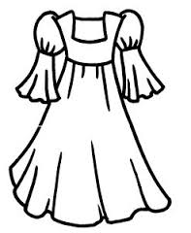 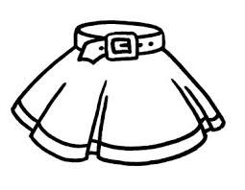 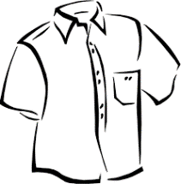 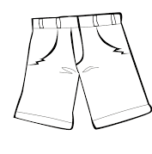

1. **Match correctly.**

duster

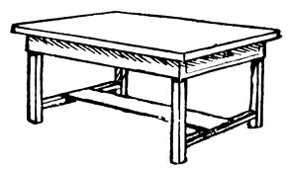 pen

bell

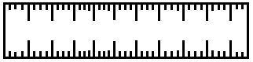

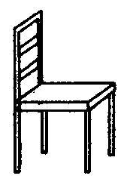 pencil

ruler

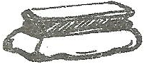

book

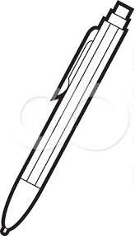

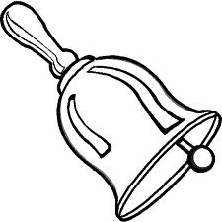 table

chair

1. **Fill in the missing letters.**

|  |  |  |
| --- | --- | --- |
|  | <http://us.123rf.com/400wm/400/400/antonbrand/antonbrand1104/antonbrand110400233/9334802-cartoon-boy-in-school-uniform-isolated-on-white.jpg> |  |
| p ___t | b ____y | gi___l |
|  |  |  |
| t___ee | c___p | b ___ll |
| D:\DESKTOP BACKUP\assesst\SAM PICTURES\SAM PICTURES2\utencils\jug3.jpg |  |  |
| j ___g | bo ___ | lea ___ |

1. **Read and draw.**

girl

cat

stool

mat

apple

teacher

1. 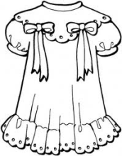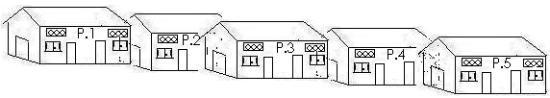**Name these pictures.**

____________ __________

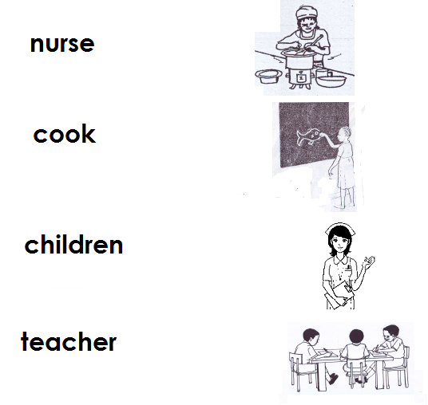

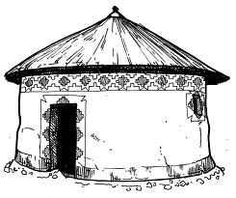

__________ _______

(dress, teacher, hut, school)

**END**